# Use Case Diagram with Narratives:

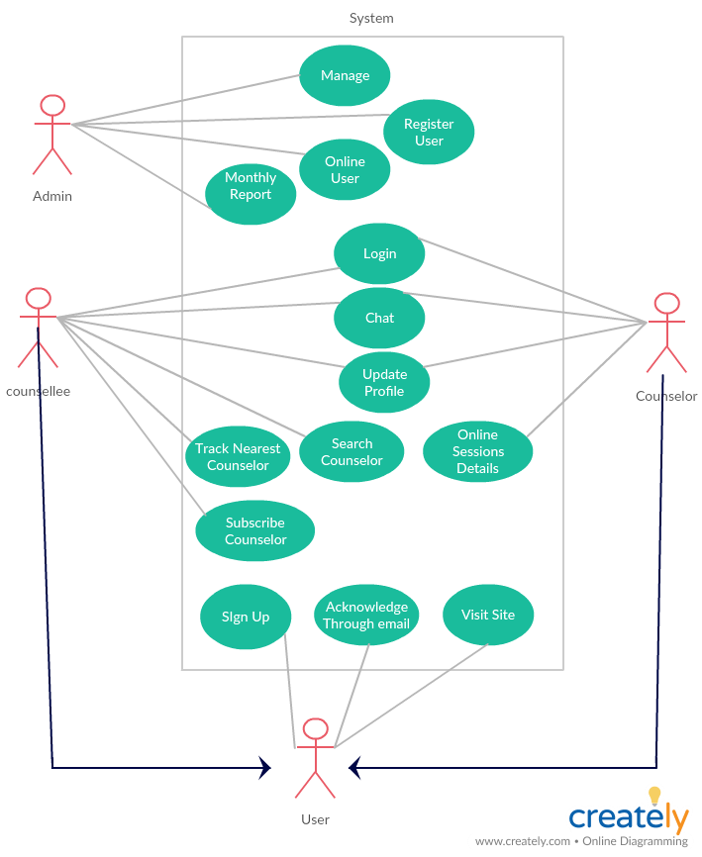



Admin

|  |  |  |  |
| --- | --- | --- | --- |
| **Author(s):** | **Ahsan, Yasin ,Mustafa** | Date: 29-July-2018  Version:  Use-Case Type  Business Requirements | |
| Use Case Name: | Manage |
| Use Case ID: | SBC-UC001 |
| Priority: | High |
| Primary Actor: | Admin | | |
| Description: | This use case is about the admin which will manage the site. | | |
| Trigger: | This use case will initiate when the admin does login | | |
| Typical Course of Events: | Actor Action | | System Response |
| Step 1: Login. | | Step 2: The system will verify and logged in the Admin. |
| Alternate Course: | If the input details went wrong, system will ask to provide authentic details. | | |
| Conclusion: | This use case concludes that the admin will manage the site. | | |



USER

|  |  |  |  |
| --- | --- | --- | --- |
| **Author(s):** | **Ahsan,Yasin,Mustafa** | Date: 29-July-2018  Version:  Use-Case Type  Business Requirements | |
| Use Case Name: | Visit Site |
| Use Case ID: | SBC-UC002 |
| Priority: | High |
| Primary Actor: | User | | |
| Description: | This Use case describes the event of a visitor who visits the site. The visitor will see the initial stuff which would be there for sale. He/she can see the initial promotions, offers and sales. | | |
| Trigger: | This use case will initiate when the user visit site and see available stuff placed there for sale. | | |
| Typical Course of Events: | Actor Action | | System Response |
| Step 1: The user visit site. | | Step 2: The system will show the all available stuff with description. |
| Alternate Course: | If the server is not available, the 404-error page would appear. | | |
| Conclusion: | This use case concludes that the system will show available stuff to the user. | | |



USER

|  |  |  |  |
| --- | --- | --- | --- |
| **Author(s):** | **Ahsan ,Yasin , Mustafa** | Date: 29-July-2018  Version:  Use-Case Type  Business Requirements | |
| Use Case Name: | Sign Up |
| Use Case ID: | SBC-UC003 |
| Priority: | High |
| Primary Actor: | User | | |
| Description: | This Use case describes the event of a visitor who will sign up to the web application. As being signed up he/she will become an official user of web application which can further lead him/her to discover the diverse ideas or functionality available on web application. | | |
| Precondition: | The user is not registered before. | | |
| Trigger: | This use case will initiate when a new user registers itself. | | |
| Typical Course of Events: | Actor Action | | System Response |
| Step 1: The new user will provide the required information to register in system. | | Step 2: The system will check that the required Information has been provided.  Step 3: The system will check the information of new user in previous database and compare some attributes. To confirm that he/she is not added before.  Step 4: The system will add the new user in database with new login ID. |
| Alternate Course: | Step 2: If the required information is not completely provided then the system Will prompt to user to provide the complete information?  Step 3: If the information of new user is matched with existed user then the System will Prompt to user and the operation will be reverted. | | |
| Conclusion: | This use case concludes that the new user is added in database or operation is Terminated. | | |
| Post Condition: | The user signed up successfully. | | |



USER

|  |  |  |  |
| --- | --- | --- | --- |
| **Author(s):** | **Ahsan, Yasin , Mustafa** | Date: 29-July-2018  Version:  Use-Case Type  Business Requirements | |
| Use Case Name: | Login |
| Use Case ID: | SBC-UC004 |
| Priority: | High |
| Primary Actor: | User | | |
| Description: | The login process required username/email address and password. This Use case describes the event of a user who will login to the site in order to sell or buy. After logging into the web application, the user will now is exposed to all functions available on web application which can entertain him/her according his/her desire. Then login process required username/email address and password. | | |
| Precondition: | SBC-UC003 | | |
| Trigger: | This use case will initiate when the user requests login to system. | | |
| Typical Course of Events: | Actor Action | | System Response |
| Step 1: The user will provide the Required information to Login into System. | | Step 2: The System will check that Required information is provided.  Step 3: The system will check the info of user in database and compare required attributes to recognize the User. |
| Alternate Course: | Step 2: If the required information is not completely providing then the system will notify to user and prompt him/her to provide complete information.  Step 3: If the system will not able to recognize the user, the system will ask the User to check the entered attributes. | | |
| Conclusion: | This use case concludes that the user must provide login ID and Password to Authenticate. | | |
| Post Condition: | The user logged in successfully. | | |



Admin

|  |  |  |  |
| --- | --- | --- | --- |
| **Author(s):** | **Ahsan ,Yasin , Mustafa** | Date: 29-July-2018  Version:  Use-Case Type  Business Requirements | |
| Use Case Name: | Register User |
| Use Case ID: | SBC-UC005 |
| Priority: | Medium |
| Primary Actor: | Admin | | |
| Description: | This use case is about the admin which will watch the register user. | | |
| Trigger: | This use case will initiate when the admin does login | | |
| Typical Course of Events: | Actor Action | | System Response |
| Step 1: Login. | | Step 2: The admin will look the all the register users. |
| Alternate Course: | If the input details went wrong, system will ask to provide authentic details. | | |
| Conclusion: | This use case concludes that how users. | | |



Admin

|  |  |  |  |
| --- | --- | --- | --- |
| **Author(s):** | **Ahsan , Yasin ,Mustafa** | Date: 29-July-2018  Version:  Use-Case Type  Business Requirements | |
| Use Case Name: | Online User |
| Use Case ID: | SBC-UC006 |
| Priority: | Low |
| Primary Actor: | Admin | | |
| Description: | This use case is about the admin will see the current online users | | |
| Trigger: | This use case will initiate when the admin wants to know the online users | | |
| Typical Course of Events: | Actor Action | | System Response |
| Step 1: | | Step 2: |
| Alternate Course: |  | | |
| Conclusion: | This use case concludes that the admin will see online users | | |



Admin

|  |  |  |  |
| --- | --- | --- | --- |
| **Author(s):** | **Ahsan , Yasin , Mustafa** | Date: 29-July-2018  Version:  Use-Case Type  Business Requirements | |
| Use Case Name: | Monthly Report |
| Use Case ID: | SBC-UC007 |
| Priority: | High |
| Primary Actor: | Admin | | |
| Description: | The admin will generate monthly report of system on the bases of major activities like how many users has been facilitate from counselors. | | |
| Trigger: | This use case will initiate when the admin wants to look the total numbers of counselors meeting with there counseelles. | | |
| Typical Course of Events: | Actor Action | | System Response |
| Step 1: | | Step 2: |
| Alternate Course: |  | | |
| Conclusion: |  | | |



User

|  |  |  |  |
| --- | --- | --- | --- |
| **Author(s):** | **Ahsan , Yasin , Mustafa** | Date: 29-July-2018  Version:  Use-Case Type  Business Requirements | |
| Use Case Name: | Chat |
| Use Case ID: | SBC-UC008 |
| Priority: | High |
| Primary Actor: | User | | |
| Description: | This use case is about the users when the counsellee and counselor interact. | | |
| Trigger: | This use case will initiate when the counsellee have some query | | |
| Typical Course of Events: | Actor Action | | System Response |
| Step 1: Find counselor of need | | Step 2: System will provide chat facility. |
| Alternate Course: |  | | |
| Conclusion: | This use case concludes counsellee can chat with counselor | | |



User

|  |  |  |  |
| --- | --- | --- | --- |
| **Author(s):** | **Ahsan , Yasin ,Mustafa** | Date: 29-July-2018  Version:  Use-Case Type  Business Requirements | |
| Use Case Name: | Update Profile |
| Use Case ID: | SBC-UC009 |
| Priority: | Medium |
| Primary Actor: | User | | |
| Description: | This use case is about user can update its current profile | | |
| Trigger: | This use case will initiate when the user want to update his or her profile. | | |
| Typical Course of Events: | Actor Action | | System Response |
| Step 1: Login. | | Step 2: The system will allow user to update his or her profile. |
| Alternate Course: |  | | |
| Conclusion: | This use case concludes that user can update his or her profile. | | |



User

|  |  |  |  |
| --- | --- | --- | --- |
| **Author(s):** | **Ahsan , Yasin ,Mustafa** | Date: 29-July-2018  Version:  Use-Case Type  Business Requirements | |
| Use Case Name: | Track Nearest counselor |
| Use Case ID: | SBC-UC010 |
| Priority: | Medium |
| Primary Actor: | User | | |
| Description: | This use case is about user when user want to search counselor of his or her near location. | | |
| Trigger: | This use case will initiate when the user wants to track counselor. | | |
| Typical Course of Events: | Actor Action | | System Response |
| Step 1: Login | | Step 2: The system will provide counselor to user of his or her near place |
| Alternate Course: |  | | |
| Conclusion: | This use case concludes that the user will get counselor of his or her near place | | |



user

|  |  |  |  |
| --- | --- | --- | --- |
| **Author(s):** | **Ahsan ,Yasin ,Mustafa** | Date: 29-July-2018  Version:  Use-Case Type  Business Requirements | |
| Use Case Name: | Search Counselor |
| Use Case ID: | SBC-UC011 |
| Priority: | Medium |
| Primary Actor: | Admin | | |
| Description: | This use case is about the admin which will manage the site. | | |
| Trigger: | This use case will initiate when the admin does login | | |
| Typical Course of Events: | Actor Action | | System Response |
| Step 1: Login. | | Step 2: The system will verify and logged in the Admin. |
| Alternate Course: | If the input details went wrong, system will ask to provide authentic details. | | |
| Conclusion: | This use case concludes that the admin will manage the site. | | |



User

|  |  |  |  |
| --- | --- | --- | --- |
| **Author(s):** | **Ahsan , Yasin , Mustafa** | Date: 29-July-2018  Version:  Use-Case Type  Business Requirements | |
| Use Case Name: | Online Session Details |
| Use Case ID: | SBC-UC012 |
| Priority: | Medium |
| Primary Actor: | User | | |
| Description: | This use case is about the user when counselor want to update there counsellee about his or her new session. | | |
| Trigger: | This use case will initiate when the counselor does login | | |
| Typical Course of Events: | Actor Action | | System Response |
| Step 1: Login. | | Step 2: The system allow counselor to update his subscribers |
| Alternate Course: |  | | |
| Conclusion: |  | | |



User

|  |  |  |  |
| --- | --- | --- | --- |
| **Author(s):** | **Ahsan , Yasin , Mustafa** | Date: 29-July-2018  Version:  Use-Case Type  Business Requirements | |
| Use Case Name: | Manage |
| Use Case ID: | SBC-UC013 |
| Priority: | Medium |
| Primary Actor: | User | | |
| Description: | This use case is about the user when counselor wants to get update from counselor. | | |
| Trigger: | This use case will initiate when the does login. | | |
| Typical Course of Events: | Actor Action | | System Response |
| Step 1: Login. | | Step 2: |
| Alternate Course: |  | | |
| Conclusion: | This use case concludes that counsellee wil get update from counselor. | | |



User

|  |  |  |  |
| --- | --- | --- | --- |
| **Author(s):** | **Ahsan , Yasin , Mustafa** | Date: 29-July-2018  Version:  Use-Case Type  Business Requirements | |
| Use Case Name: | Acknowledge Through Email |
| Use Case ID: | SBC-UC014 |
| Priority: | Medium |
| Primary Actor: | User | | |
| Description: | This use case is about the user when user want to get update through his email. | | |
| Trigger: | This use case will initiate when the user will provide email to system. | | |
| Typical Course of Events: | Actor Action | | System Response |
| Step 1: Login. | | Step 2: The system will verify user email. |
| Alternate Course: |  | | |
| Conclusion: | This use case concludes that after verification user will get information through email. | | |